Abdullah Zafar

17001340

Mobile applications development

Report – 2CWK50

Wireframes

The design stage is the most important stage of development. A well thought out design is what allows delivery of a complete product which meets the requirements. I used wireframes to design the application’s layout and structure. This allowed me to reflect on the applications flow, layout and design aspects. Below I have included all the stages the wireframes went through during development, alongside explanations.

Evidence Wireframes:

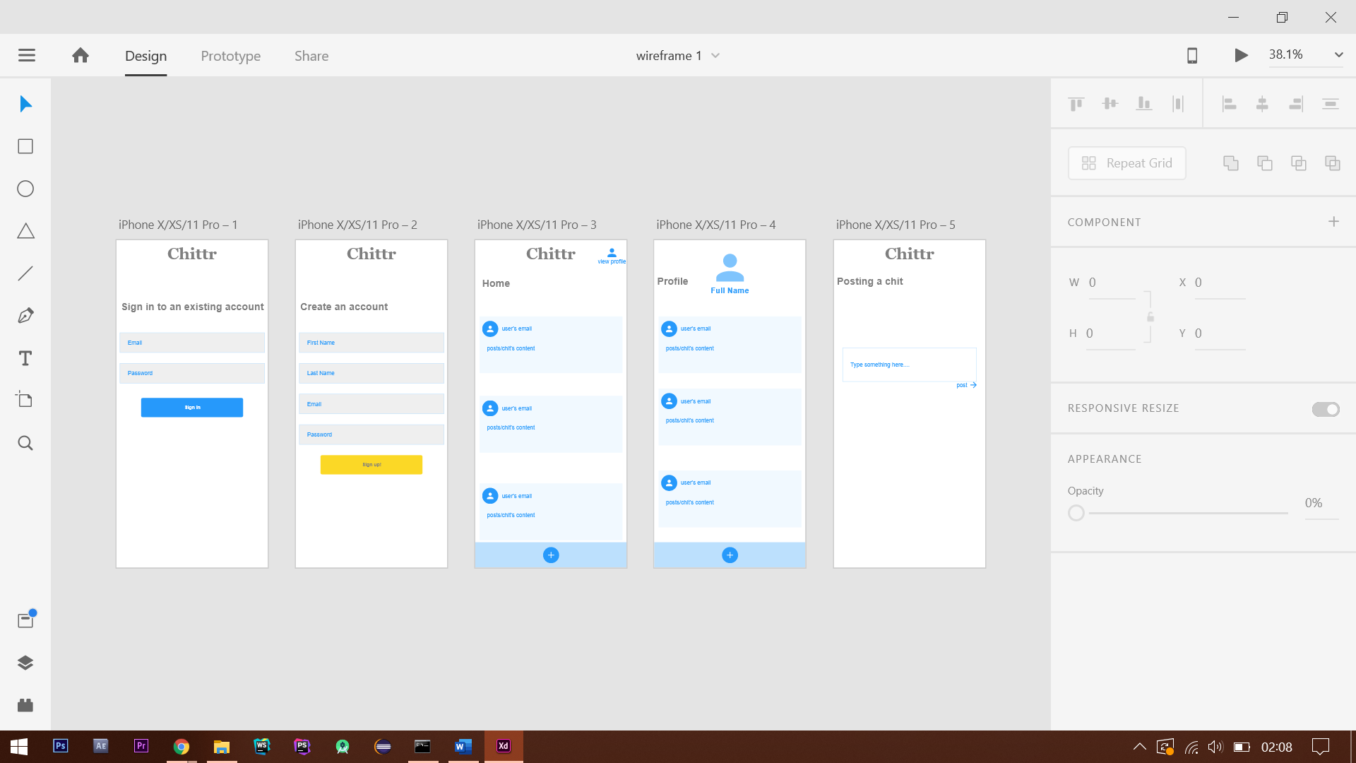Version 1 -

Figure 1 First version of wireframe

Above is the first version created, it shows the application will consist of five screens; ‘Sign in’, ‘Sign up’, ‘Homepage’, ‘Profile’ and ‘Dashboard’. Since the purpose of a wireframe is to determine the layout of the content and functionality, the design was kept simple and the focus was first to cover these areas. Both the ‘sign in’ and ‘sign up’ pages were straightforward to design as they only required input fields and submit buttons which allowed navigation to the next page. The ‘Homepage’ is loaded after pressing the ‘sign in’/’sing up’ button. Chit contents are displayed in the main section of the page, with an ‘Add’ button at the bottom, which allows the user to add a chit. A button is positioned at the top of the page which allows the user to access the ‘Profile page’. Here the user’s picture is displayed with their username, below which the user’s chits are displayed. Similar to the ‘homepage’, the button to add a chit is placed at the bottom of the page which leads to the ‘post a chit’ page. Here an input field and a button are displayed to post the chit. This wireframe design mainly reflects the layout of the content and the functional aspects of the application is not considered. For instance, it lacks basic navigation. The user is unable to go back to the previous page due to the lack of ‘Back’ buttons. Similarly, functionality to edit or delete accounts, search for users so the user can unfollow or follow a user based on the specific ID is also not implemented, alongside various other elements.

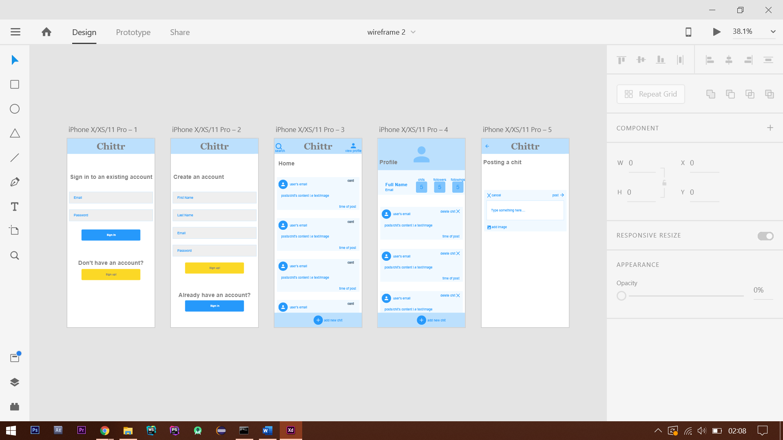Version 2 -

Figure 2 Shows the second version of the wireframe

This is the second version of the wireframe; many features which were absent in the initial design have been implemented. For instance, users now have the option to delete their chits, both previously posted (4th page) and any new being created (5th page). The option of attaching an image to a chit is also now included. Similarly, a counter of the number of chits posted along with the number of followers and following is displayed under the user's profile. The login pages now provide the option of either choosing from signing up or signing in with an existing account. This improves user experience as it’s assisting the user to make it easier to use the application. Additional features such as displaying the time when the chit was posted aids in improving the user experience. Finally, to ensure consistency of appearance, a banner has been added which gives the application a professional appearance, this was further ensured through the use of the same text font and by keeping consistent with the layout of the content. This was a much-improved wireframe in view of the design in comparison to the previous as it met the majority of the specification and was more complete. There are still essential features which are lacking such as being able to edit your profile, being able to see the followers and following list, shows the application still can be improved upon.

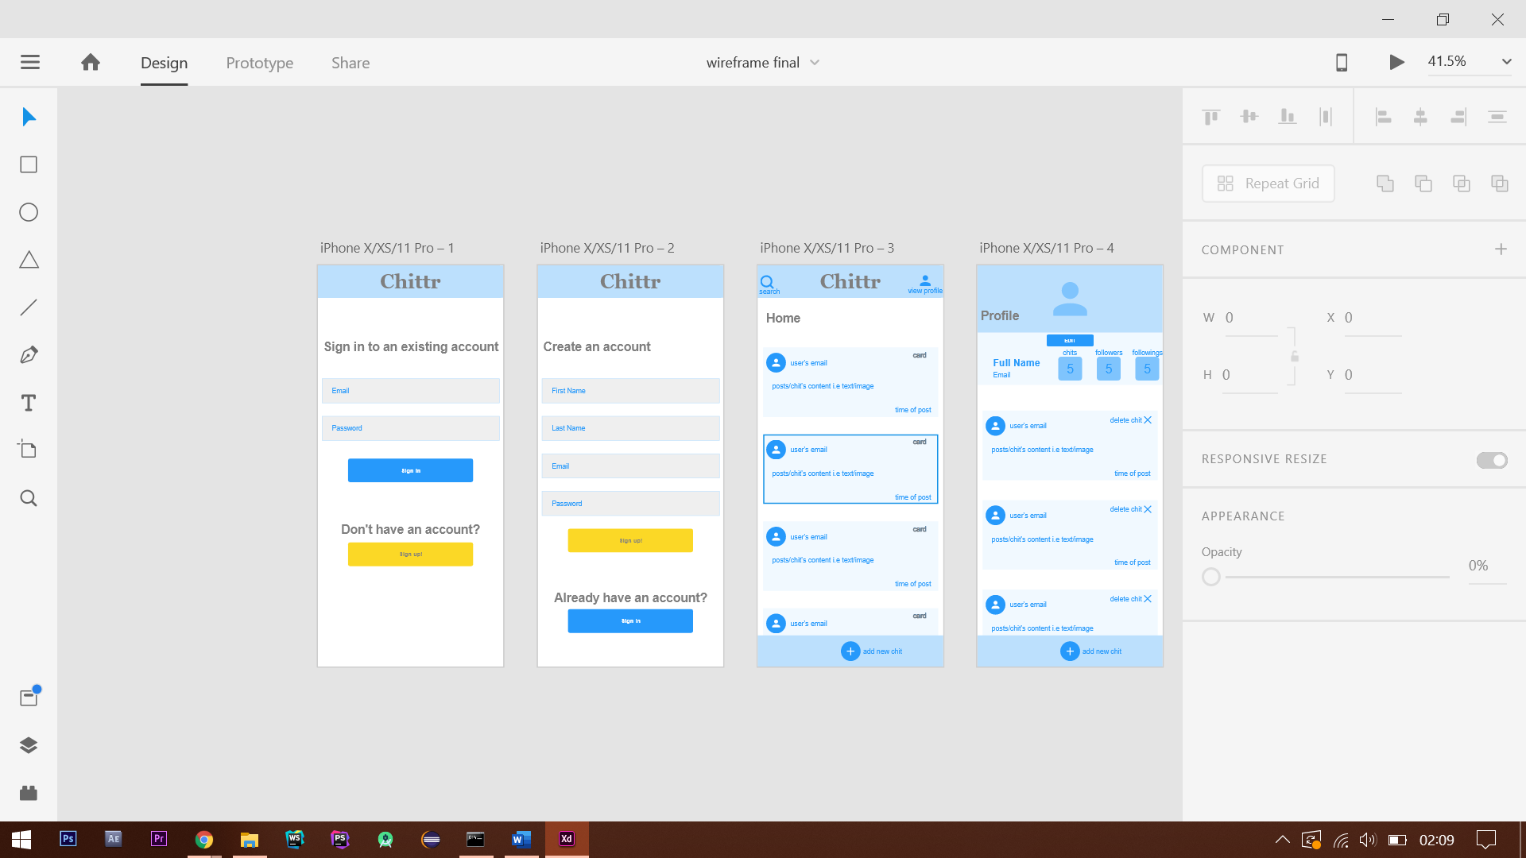Final -

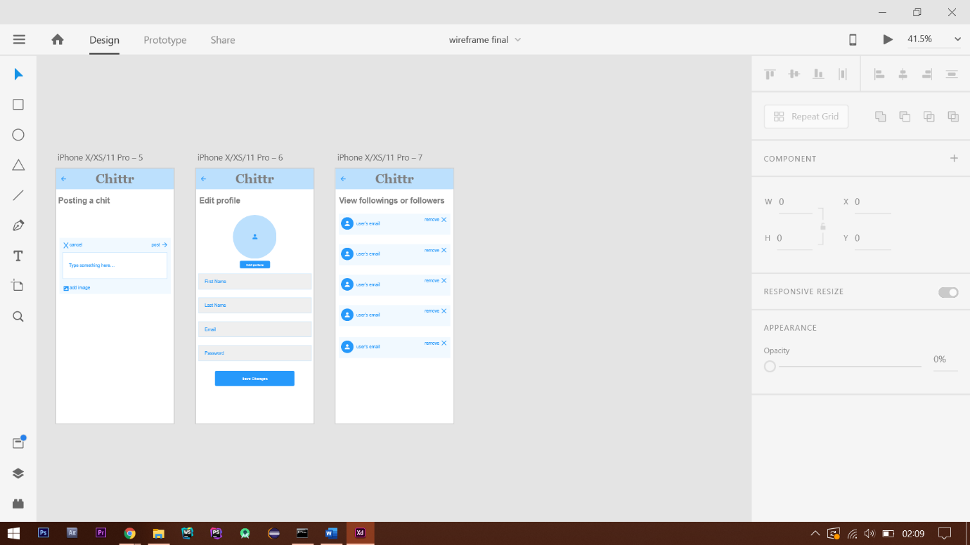

Figure 3 - Final version of the wireframe

The finalised wireframe has been designed, covering areas in which the previous versions lacked in. The user is now able to edit their profiles, they can add a picture to their profile and edit their details. To ensure good user experience, I have added this content on an additional page, instead of including this functionality to the same ‘Profile’ page. This was done to prevent cluttering and create an intuitive interface. I have also added another page, which will display a list of the users’ followed and following. The user will be able to remove/unfollow users, due to the incorporation of a ‘remove’ button. With this addition, it means this requirement has been met. Also, I have ensured that navigation is applied through the application, ‘back’ buttons have been added, and the user can now navigate through the application.

Version Control

To manage my project, I decided to use a method of version control. Version control allows management of projects by keeping track of the changes made to files over time. I decided to use GitHub since I have prior experience from having used it to manage a project last year.

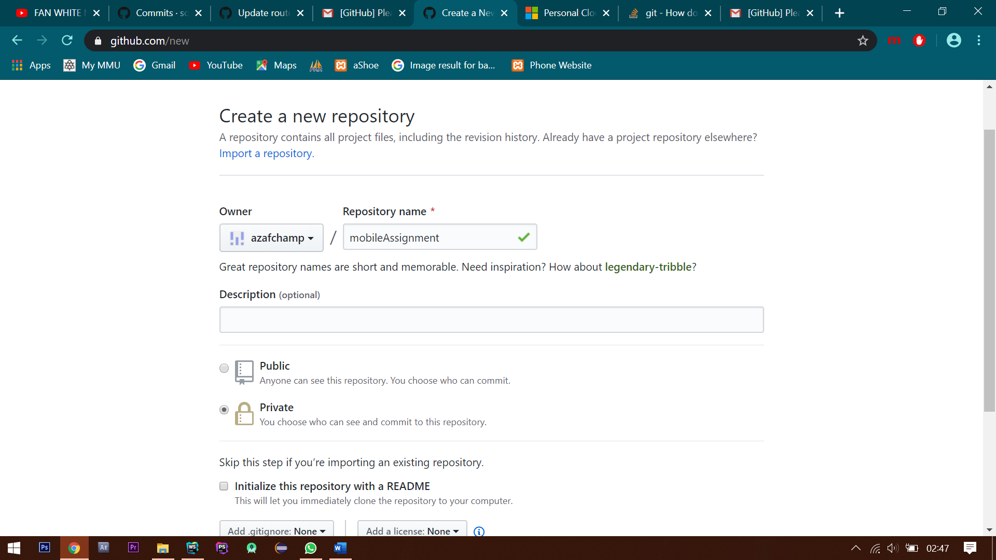

Figure 4 shows how the GitHub repo was created

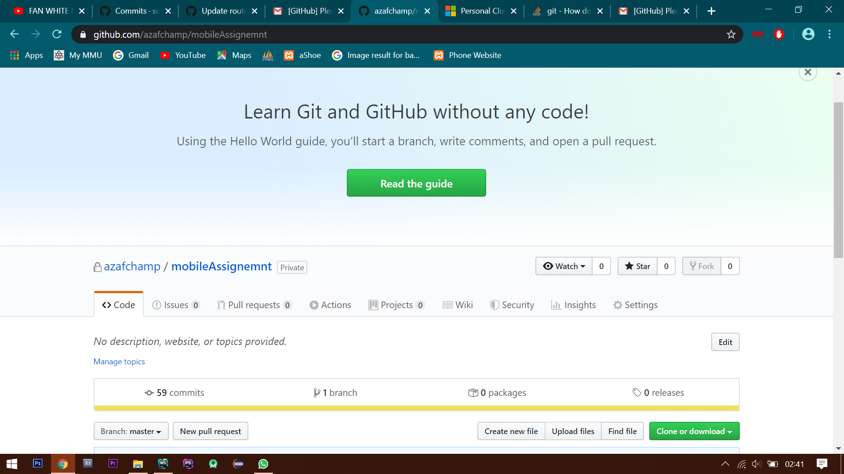

Figure 4.1 shows GitHub repo during this assignment

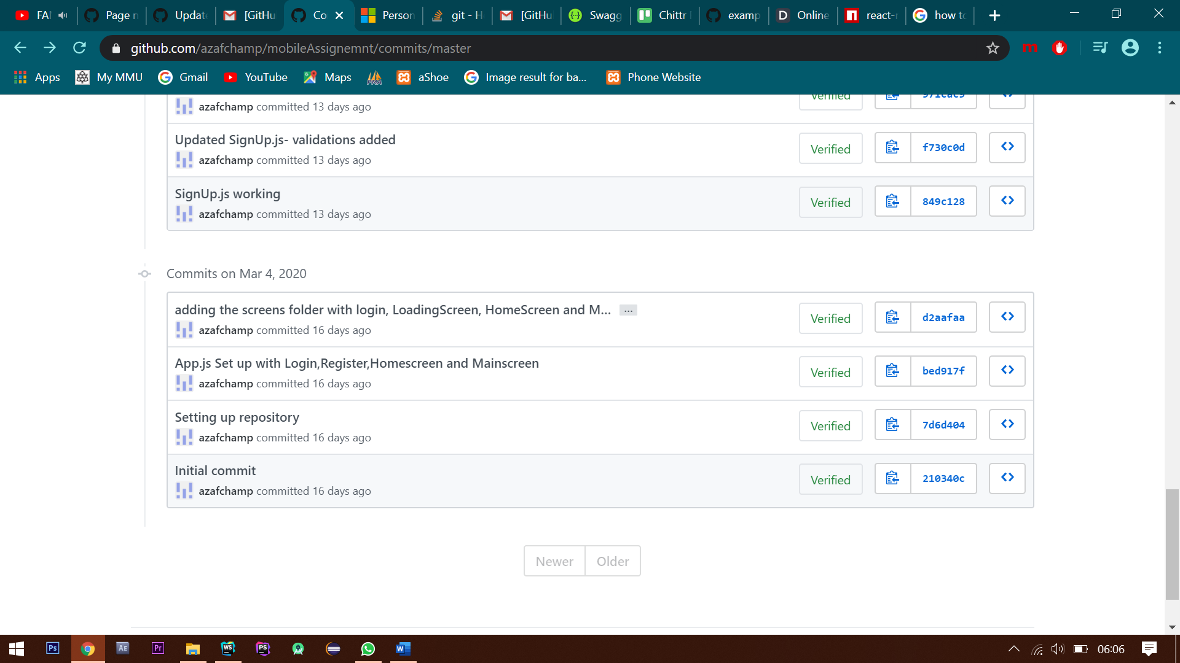

Figure 4.2 shows commits on 4th of march

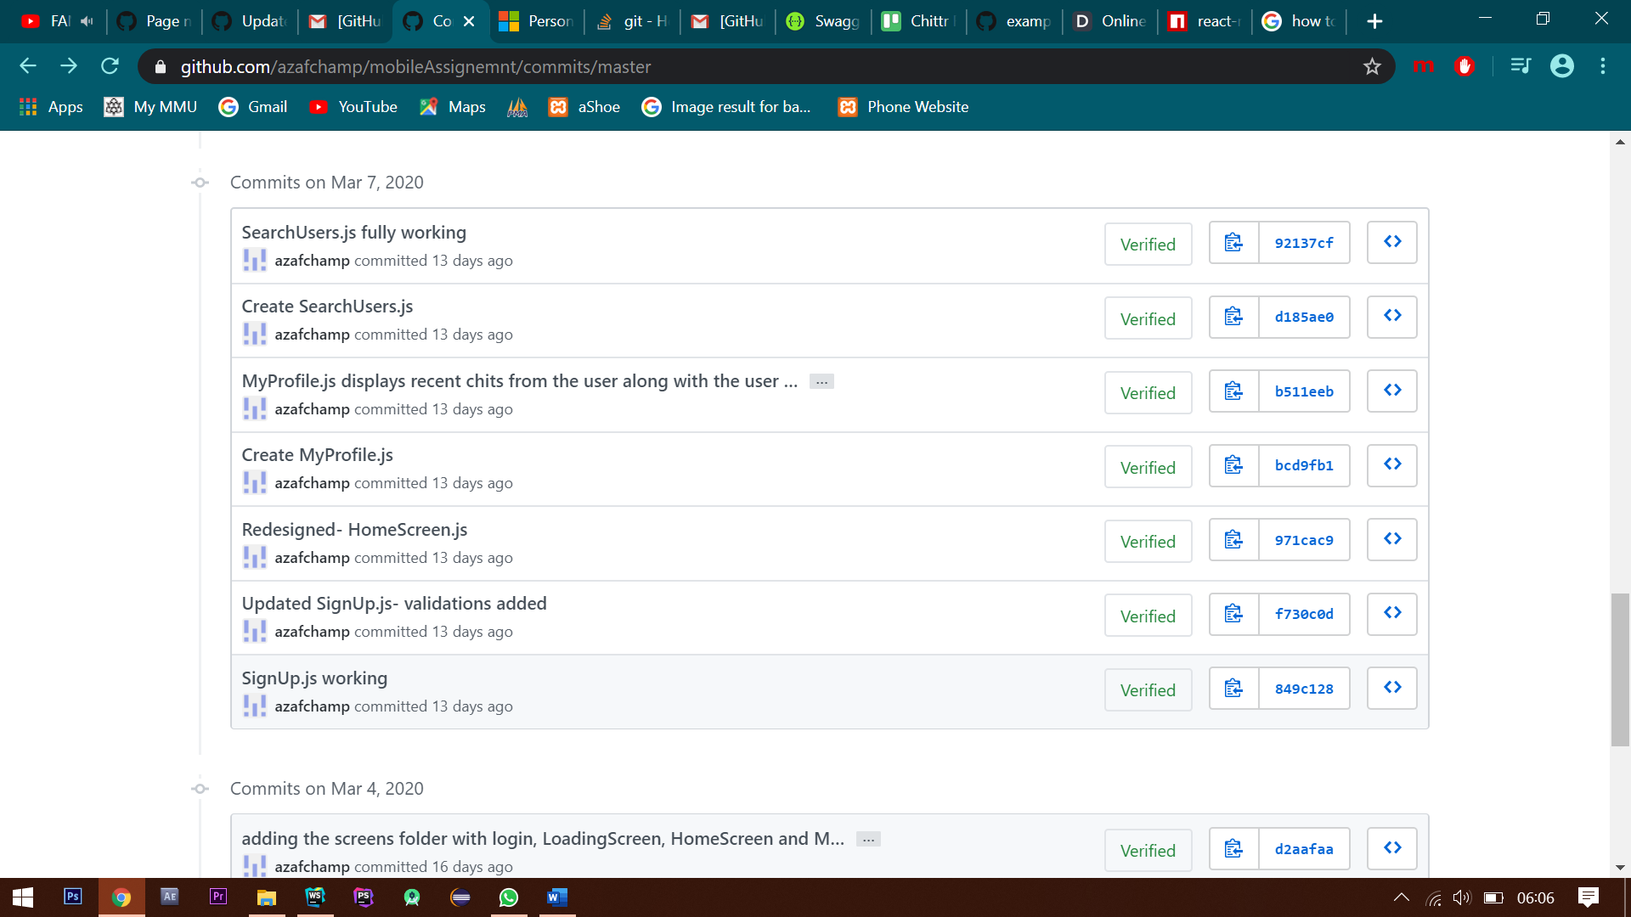

Figure 4.3 shows commits on 7th of march

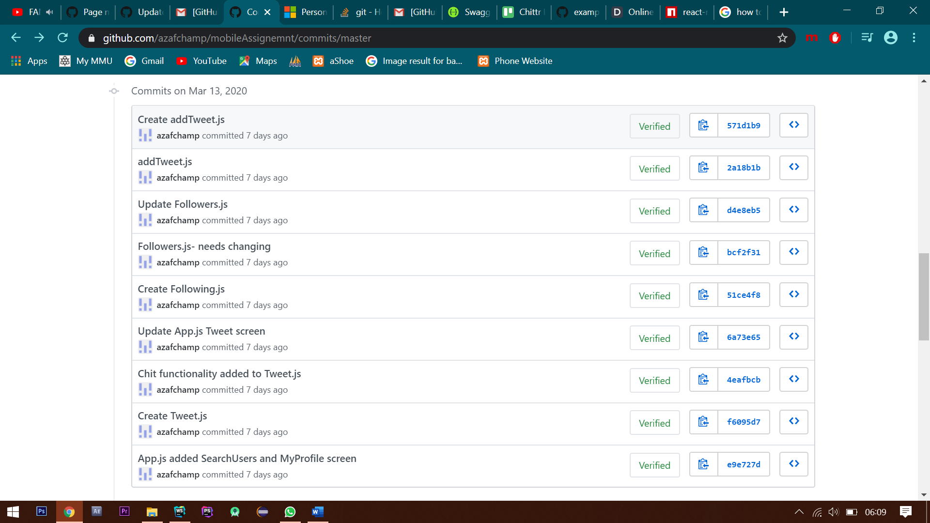

Figure 4.4 shows commits on 13th of march

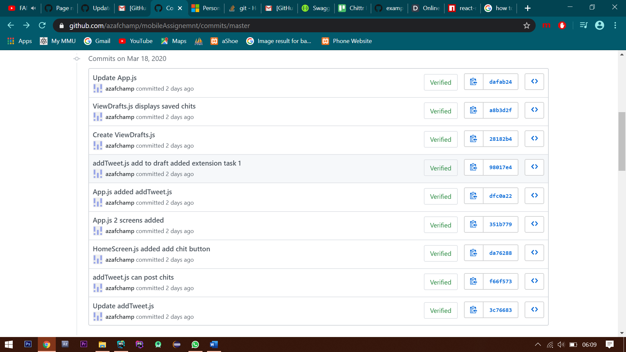

Figure 4.5 shows commits on 18th of march

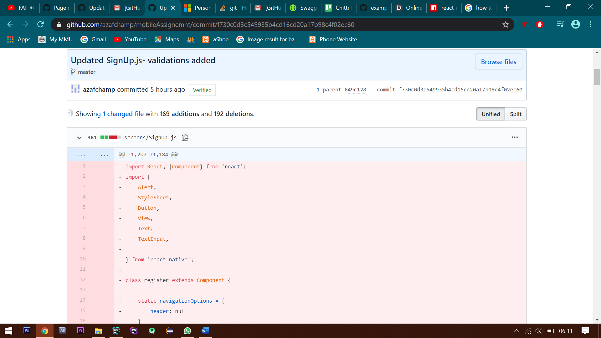

Figure 4.6 shows a commit in detail

I began by creating a new repository and uploading my project files as I made significant changes to it (figure 4). I ensured that I maintained this throughout the project. A selection of commit can be seen in the figures 4.1, 4.2, 4.3, 4.4 and 4.5 which shows the use GitHub repository during the entire period of this assignment. Furthermore, a commit is shows in more detail in the figure 4.6

Code Quality-

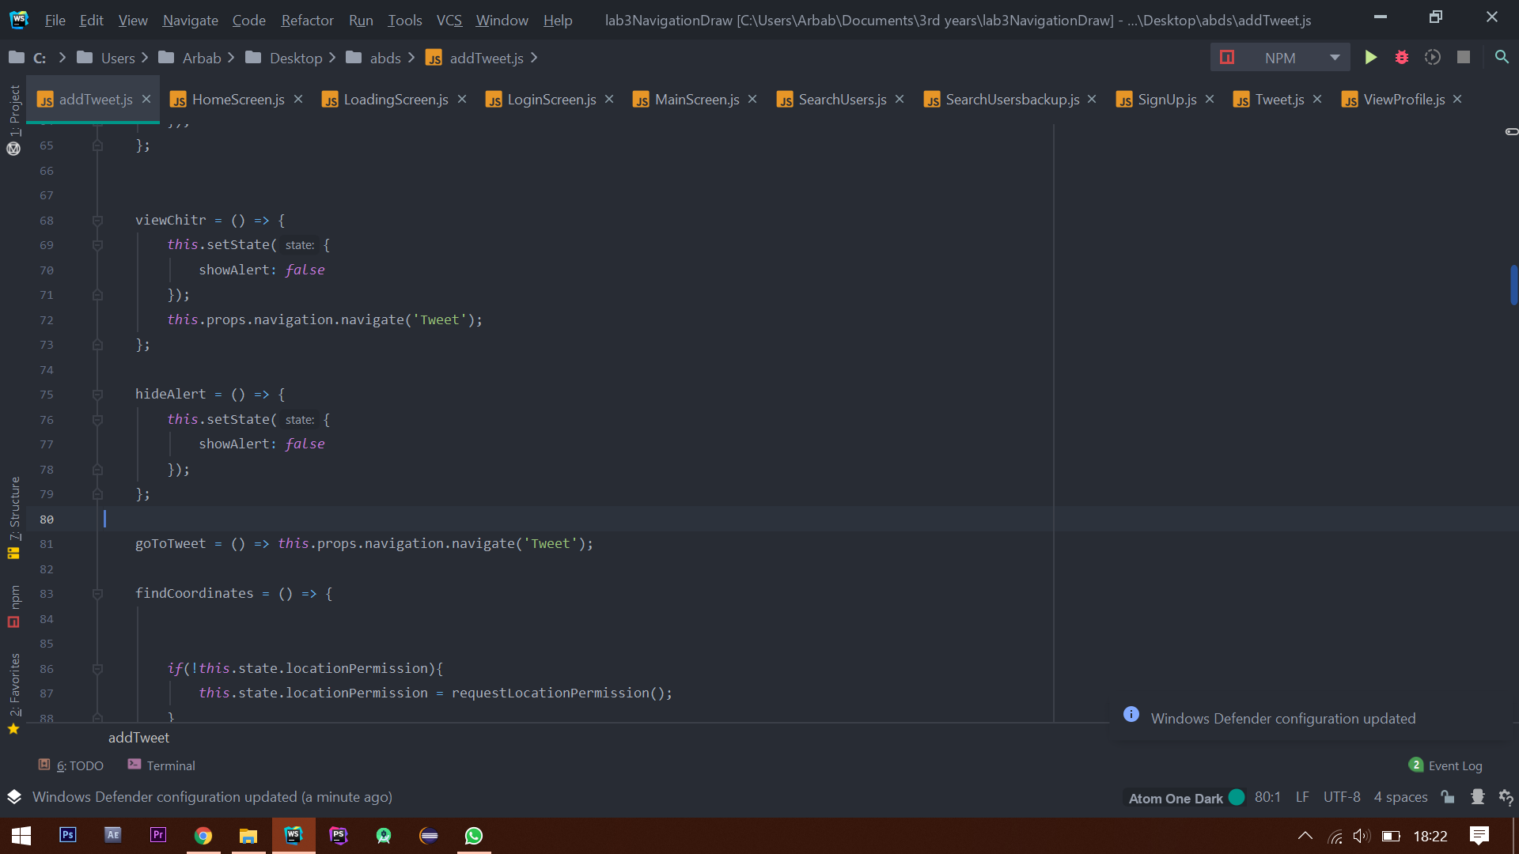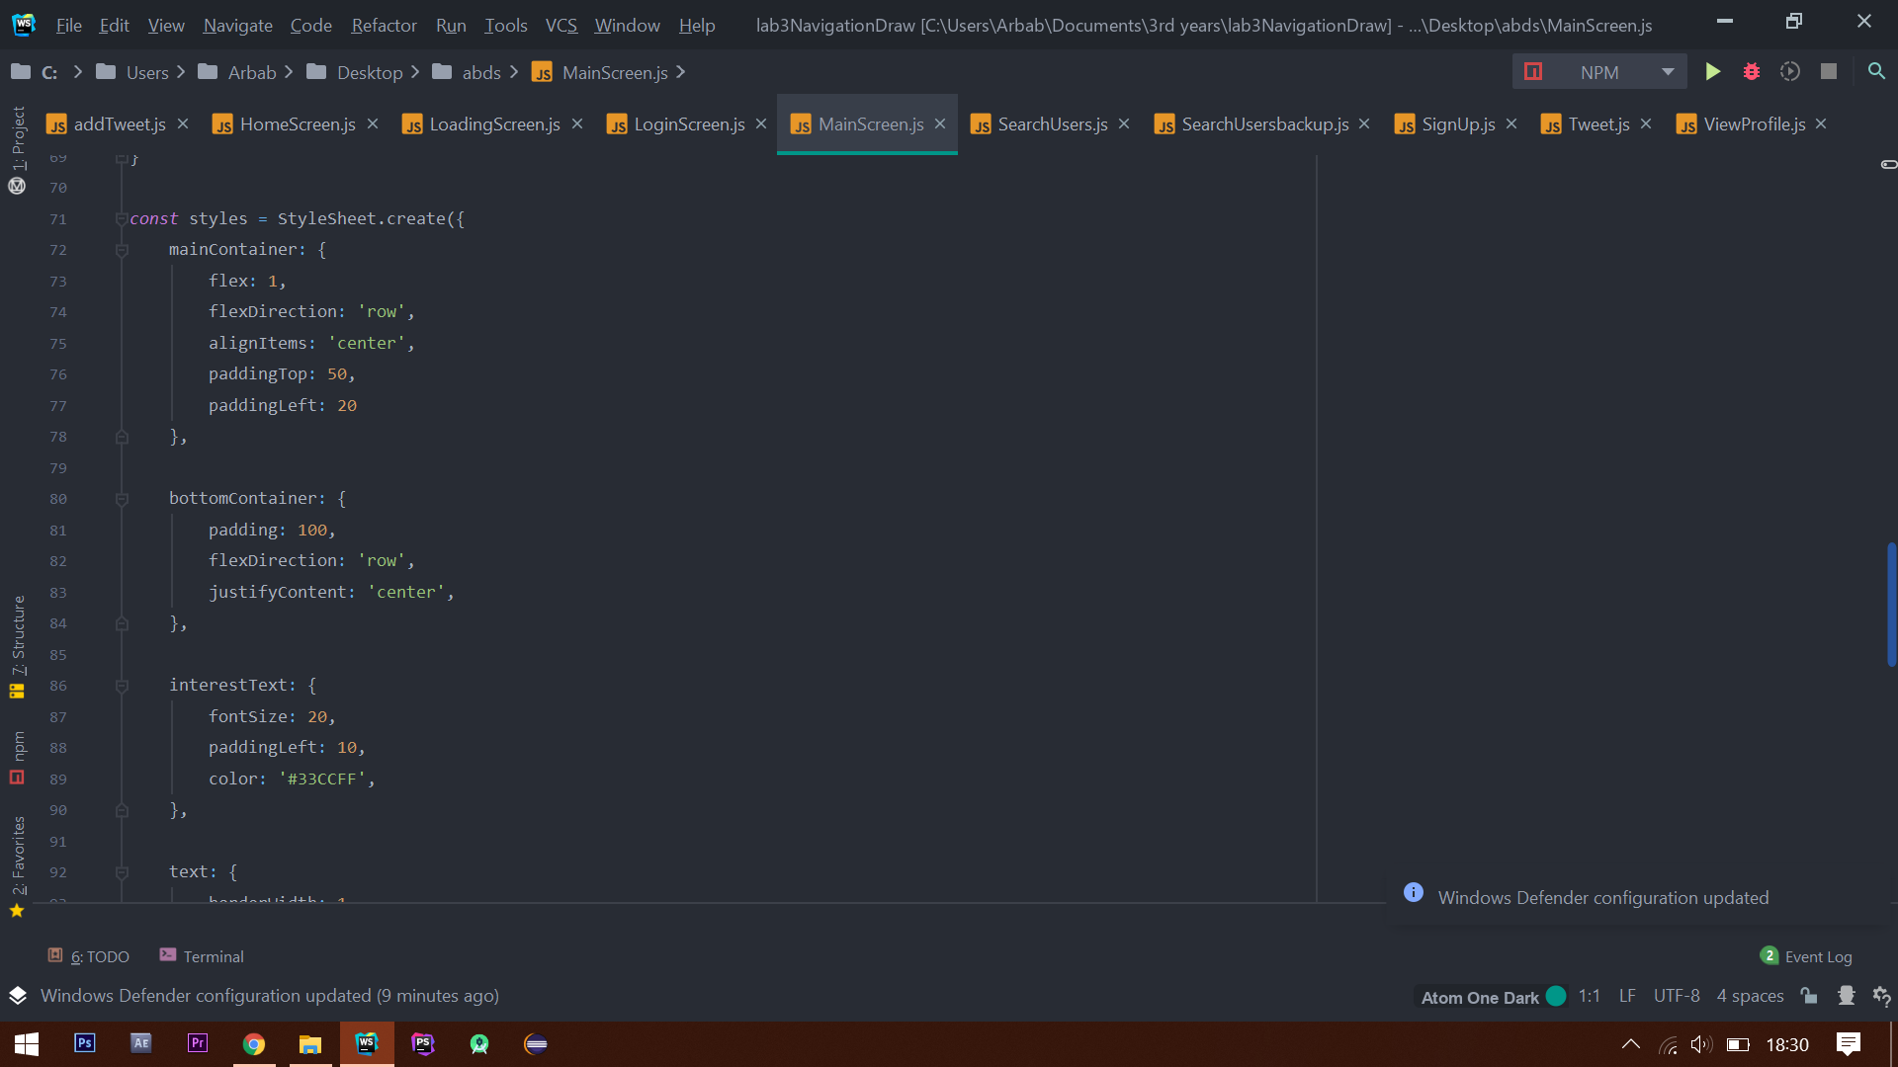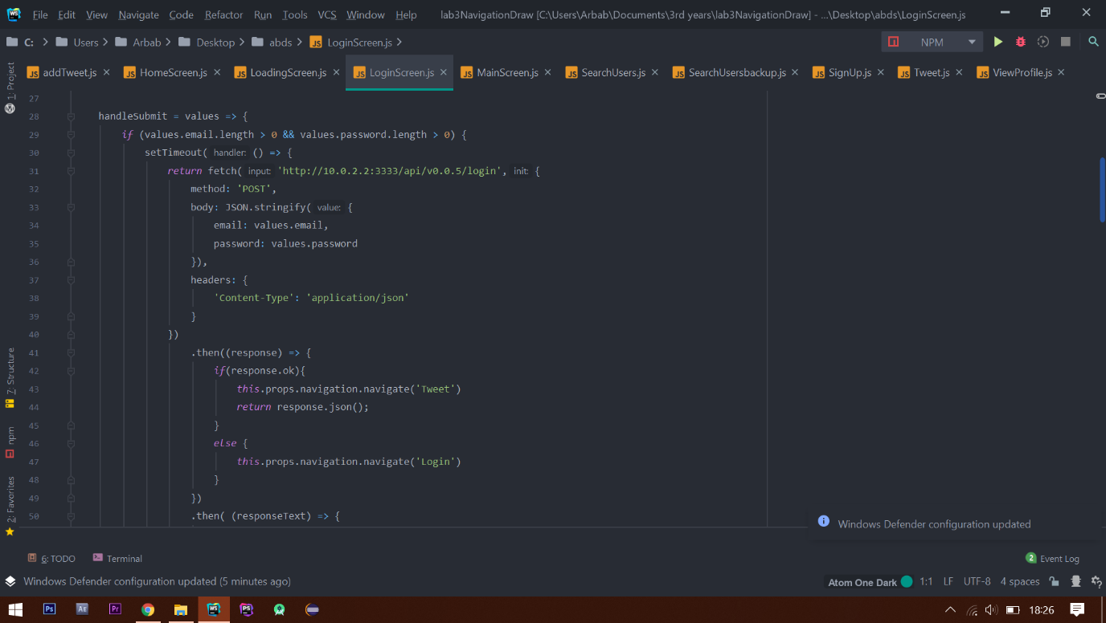

Figure 5.3 Shows the function getUserData in the ViewProfile.js file

Figure 5.2 Shows the code towards the end of the MainScreen.js

Figure 6: Shows a section of a code in LoginScreen,js

Figure 5.1 Shows a section of a code in LoginScreen,js

Figure 5 Shows a section of a code in the addTweet.js file

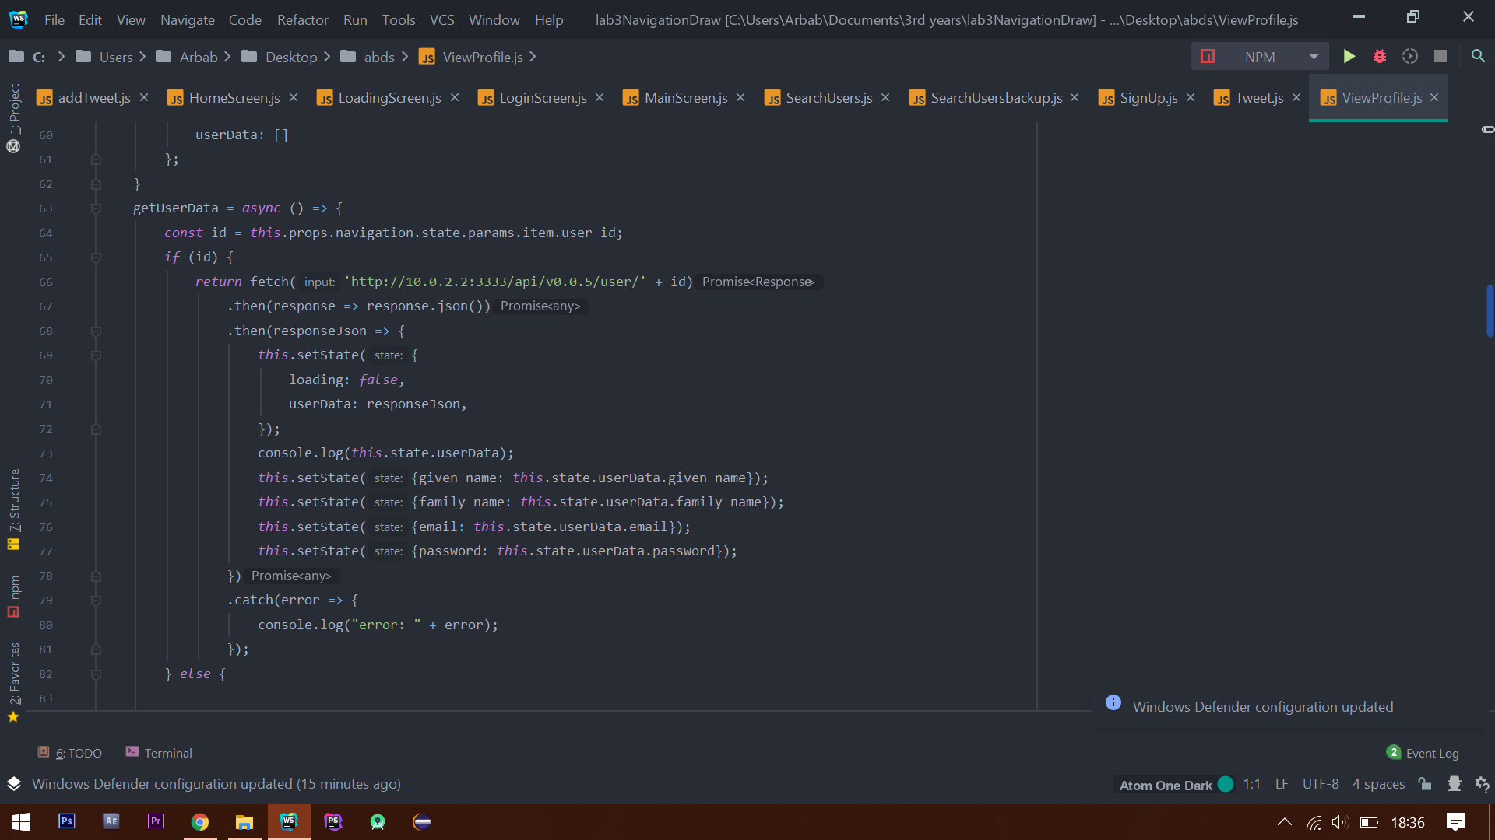

Throughout the project, I have used consistent style indentation (Figure 5 and Figure 5.1) alongside naming conventions which can be deemed self-explanatory. An example is the function named ‘getUserData’ (Figure 5.3). It fetches the user data from the database, which can easily be presumed by the functions name. This also shows the use of camel case which is another good coding practice as it makes multi-word domains more readable. More examples of this can be seen in Figure 5. Additionally, I ensured the style code is either kept at the bottom or the top of each file so If I have to make changes to the design, I will know where to look for the code immediately. I also limited each line length (block-like format) to make the code more readable (shown in Figure 5.2 and Figure 5.1).

Project Management - Kanban:

After researching into the various development methodologies, I decided to implement KANBAN. It was suitable for my project for a variety of reasons. It allowed me to split the project into manageable sections, track progress and make improvements at any stage through development. I decided to use Trello which is a web-based KANBAN application, it meant it was an appropriate tool for managing workflow.

I created two boards on Trello, first being ‘Application Design’ which contains all information relating to the design of the application such as wireframes. The second board ‘Implementing Functionality’ was used to document the functionality aspect of the application.

Below I have included evidence on how I used Trello to manage my project.

* Implementing Functionality

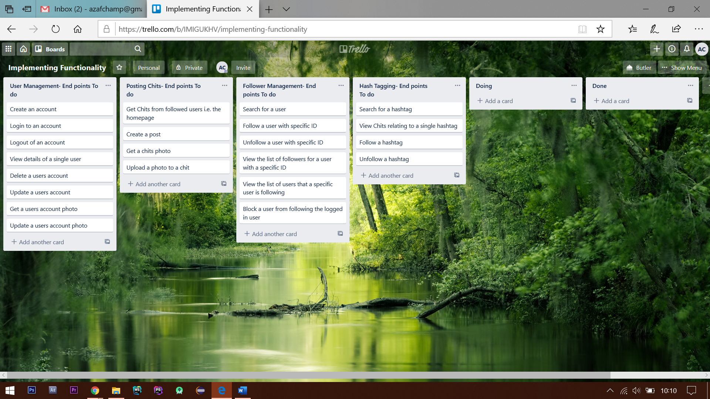

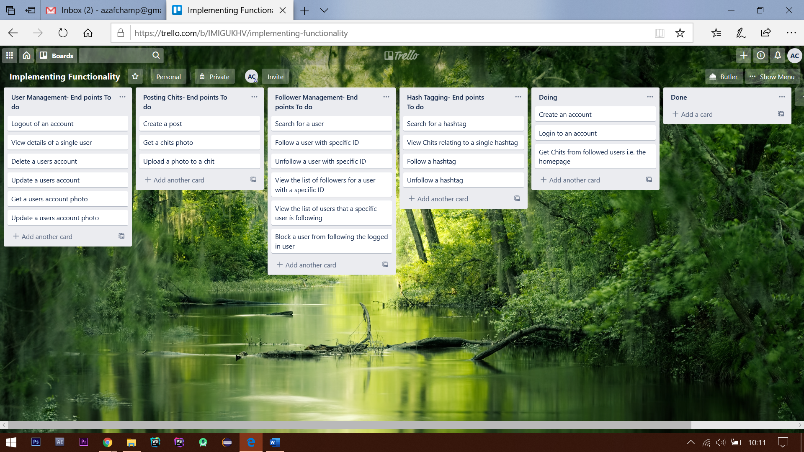

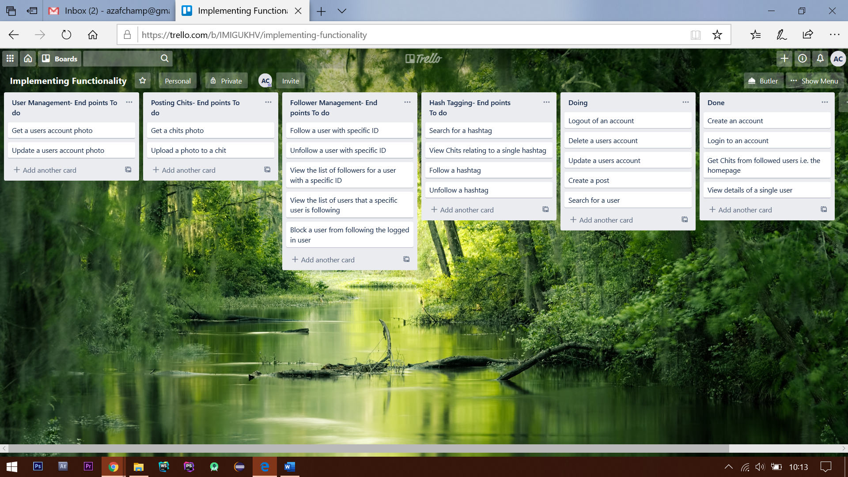

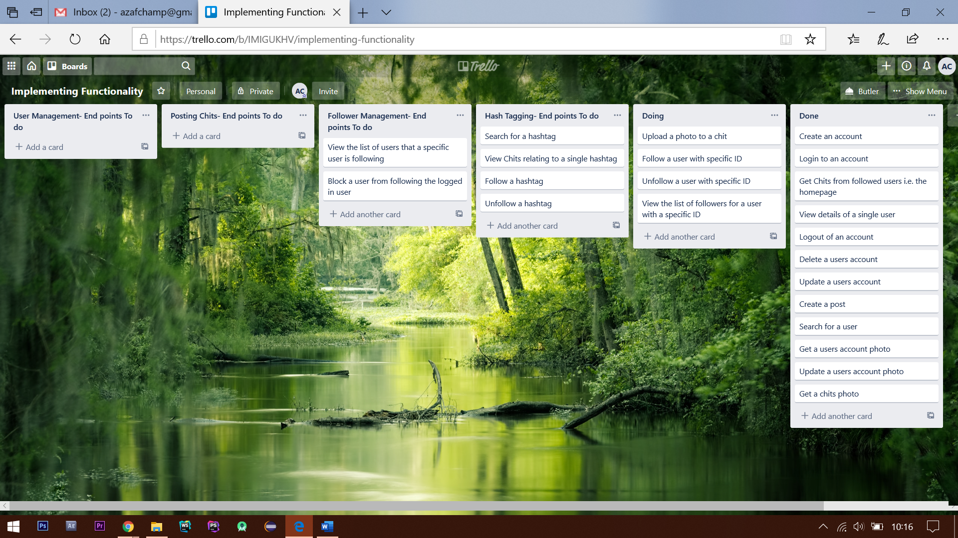

Figure Shows the 'implementing functionality' board

To maintain clarity, I began by creating cards such as ‘create an account', which represent an individual task and placed these together in a list. By splitting up tasks, it became easier to keep track of how many tasks were incomplete and which had been completed. I also created another two lists; each was dedicated to an individual area such as chits and followers. By doing so I was able to assign a separate section for them, which made it easier to keep track of the progress and ensure no feature was missed. As you can see, as I began working on a certain area its corresponding card was moved onto the ‘doing’ list. Likewise, as each task was completed it was moved on the ‘done’ list.

* Application Design

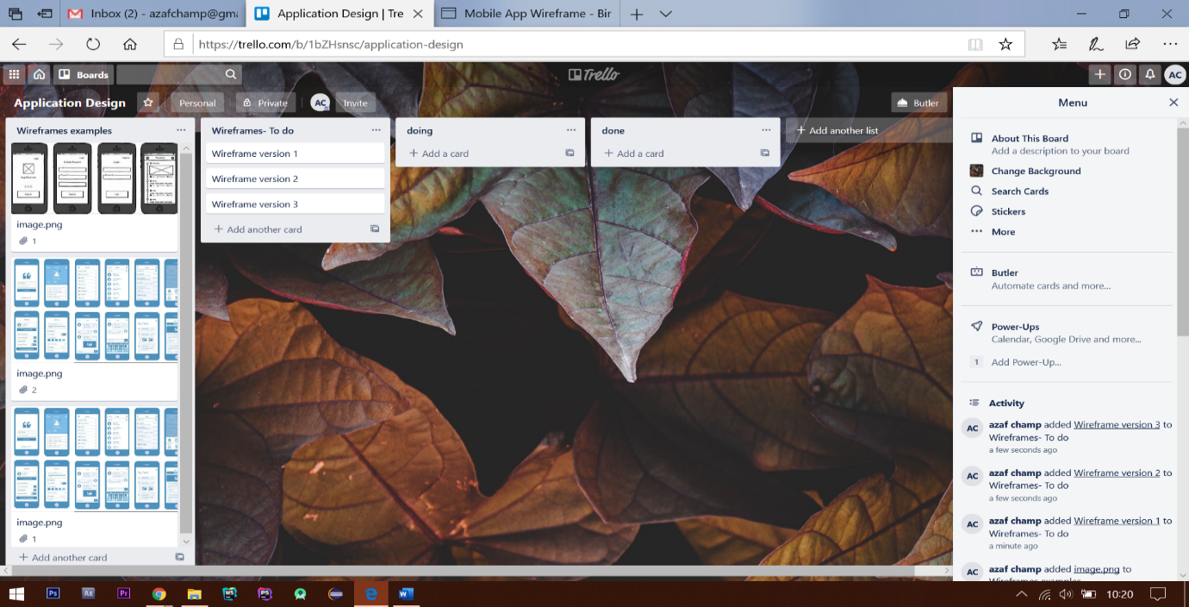

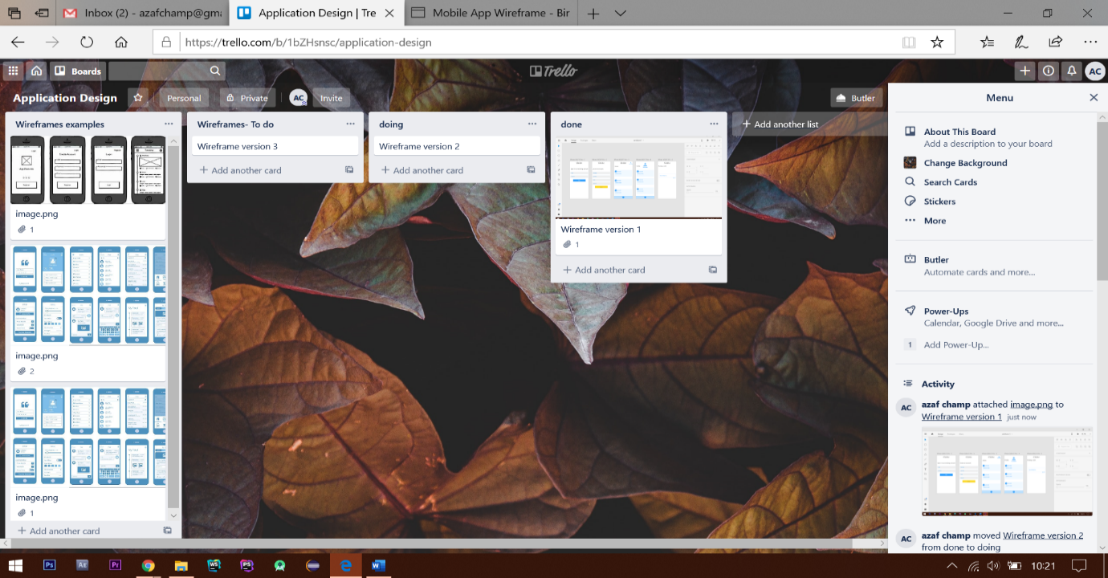

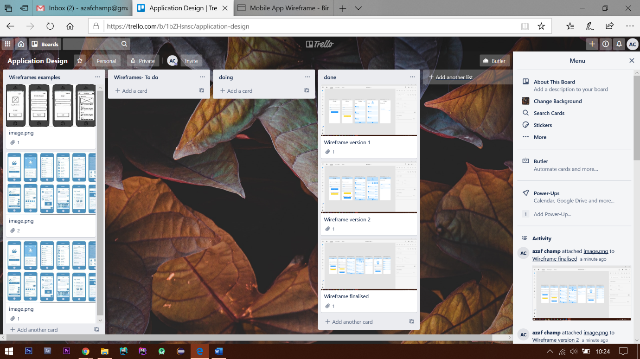

Figure 7 Shows the Application Design board and its lists

As shown in the above I included four lists; ‘wireframes examples’, ‘wireframe- To do’, ‘Doing’, ‘Done’. The ‘wireframes examples’ list is where I kept all the research material. To ensure I was well informed when creating my wireframes, I ensured that I conducted considerable research relating to how to create appropriate wireframes since the design stage is one of the most important stages of development. The second list ‘wireframes -To do’, here I created three cards presenting each version of the wireframe. By doing so, I was able to keep track of the progress, as each version was worked on it was moved to the ‘doing’ list and eventually onto the ‘d one’ list indicating completion.